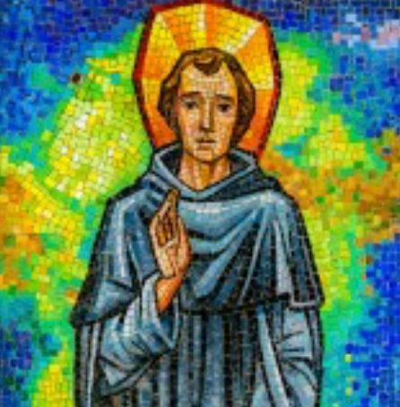

St Peregrine Devotions – LOUGHSHORE PARISHES

Entrance Hymn:

Welcome
C Lord, you invite all who are burdened to come to you.
In that spirit, we come in prayer asking for your
healing touch on those who suffer from injury, illness
or other heavy burdens. Touch their hearts with your
courage and infinite love. Teach them to reach out to
you in their need, and help them to lead others to you
by their example. Bring them health in body and spirit
that they may serve you with all their strength. Touch
gently their lives, which you have created for your
glory, now and forever. Amen.

ACT OF REPENTANCE
C My brothers and sisters, to prepare ourselves to
receive God’s gifts of mercy and healing let us call to
mind our sins.

C I confess to Almighty God, and to you my brothers
and sisters, that I have greatly sinned, in my
thoughts and in my words, in what I have done and
in what I have failed to do, through my fault, through
my fault, through my most grievous fault. Therefore I ask Blessed Mary, ever Virgin, all the
angels and saints and you, my brothers and sisters,
to pray for me to the Lord our God.

C May Almighty God have mercy on us,
forgive us our sins and bring us to everlasting life.
P. Amen.

Prayer to St. Peregrine
C. Let us pray:
P. As we come together this day we know, St.
Peregrine, that you are a powerful intercessor,
because your life was completely given to God. We
know that, in as much as you pray for our healing,
you pray even more for our salvation. A life of holiness like yours is more important than a life free
of suffering and disease. So, we pray not only for our
healing, but even more that we might grow as close
to the Lord as you are.

C Glory be to the Father, and to the Son, and to the Holy
Spirit,
P. as it was in the beginning is now and ever shall be,
world without end. Amen

GOSPEL

Intercessions – aLL kNEEL
P. Dear St. Peregrine, holy servant of God,
We pray today for healing. Intercede for us!
God healed you of cancer and others were healed by
your prayers. These intentions bring us to our knees,
seeking your intercession for healing. We are
humbled by our physical limitations and ailments.
We are so weak and powerless. We are completely
dependent upon God. And so, we ask that you pray
for us…

C. * that we will not let sickness bring us to despair: R./
St Peregrine, pray for us.
* that we may persevere in hope: R./
* that we have the courage to offer up our suffering in
unity with the Cross: R./
* that the loneliness of our suffering will be consoled: R./
* that the fear of death will be replaced with the hope
of everlasting life: R./
* that our suffering will not rob us of joy: R./
* that in our pain we will not become selfish but ever
more selfless: R./
* that our sickness will teach us to depend more and
more on God: R./
* that our lives will glorify God alone: R./

C. In the silence of our hearts we bring before the Lord
all our other personal intentions.

C. We pray...
P. St Peregrine, pray for us.
C Mary, Mother of the Sick, P. pray for us.

C. Let us pray:
P. God, our Father and Lord of all consolation, your Son
suffered and died so that we might have life. We
praise the wonder of your love for us in the example
of your servant Peregrine. Through his intercession,
help us to open our lives to your healing for us. May
we listen to your word and do your blessed will. We
ask this through Christ our Lord. Amen.

tHE rOSARY
c. We now pray the five decades of the Rosary, praying
the five joyful Mysteries. We begin with the Apostles’
Creed.

I believe in God, the Father Almighty, Creator of
Heaven and earth;
and in Jesus Christ, His only Son Our Lord,
who was conceived by the Holy Spirit,
born of the Virgin Mary,
suffered under Pontius Pilate,
was crucified, died, and was buried.
He descended into Hell;
the third day He rose again from the dead;
He ascended into Heaven,
and is seated at the right hand of God,
the Father almighty;
from there He shall come to judge the living and the
dead.
I believe in the Holy Spirit, the holy Catholic Church,
the communion of saints,
the forgiveness of sins, the resurrection of the body
and life everlasting. Amen.

Our Father, Hail Mary x3, Glory Be.

THE ANNUNCIATION
The angel Gabriel announces to Mary that God has
chosen her to be the mother of his Son. Mary
declares, “I am the handmaid of the Lord. Let what
you have said be done unto me.”

THE VISITATION
Mary visits her cousin Elizabeth. John the Baptist, in
his mother’s womb, leaps for joy to be in the presence
of the unborn Messiah. Mary prays her Magnificat in thankfulness for the faithfulness and mercy of God.

THE NATIVITY
Jesus is born in Bethlehem. The angel choir sings Glory
to God. Shepherds and Kings bow down before him in
humble adoration.

THE PRESENTATION IN THE TEMPLE
Mary and Joseph present the baby Jesus in the Temple
in Jerusalem. Simeon acclaims Jesus the light to
enlighten the Gentiles and the glory of Israel. He
foretells the sufferings of Mary. Anna recognises Jesus
as the Messiah and tells everyone about him.

THE FINDING IN THE TEMPLE
The young Jesus is found among the scholars in the
temple, astonishing all his listeners with his wisdom.
He declares that he must be about his Father’s
business, but returns with Mary and Joseph to
Nazareth to live under their authority

HAIL HOLY QUEEN AND CONCLUDING PRAYERS

CONCLUDING PRAYER
C. O God, you are the source of health and healing.
May your hand rest upon all in our community in
need of your healing touch. May the life-giving
powers of your touch flow into every cell of their
bodies and into the depths of their souls, cleansing,
purifying, restoring them to wholeness and strength
for service to your Kingdom.
And may your blessing come upon them and remain
with them always.

P. Amen.

BLESSING
C. Bow your heads and pray for God’s blessing.

May the Lord, our Saviour, give us patience and
strength in the hour of trial.
P. Amen

C. May He console us in affliction and free us from all
evil.
P. Amen.

C. May He heal our wounds and lead us to live in peace
and serenity.
P. Amen

C. (with the relic of St Peregrine)
Through the intercession of St Peregrine, may the Lord
bless us, keep us free from all evil and lead us to life
everlasting. And may almighty God bless you, the
Father, and the Son and the Holy Spirit.
P. Amen.

C. Let us bless the Lord.
P. Thanks be to God.

